Domain Controller

Step 1- Go to Virtual machines menu in left navigation and click on Add button. Click on Windows Server icon

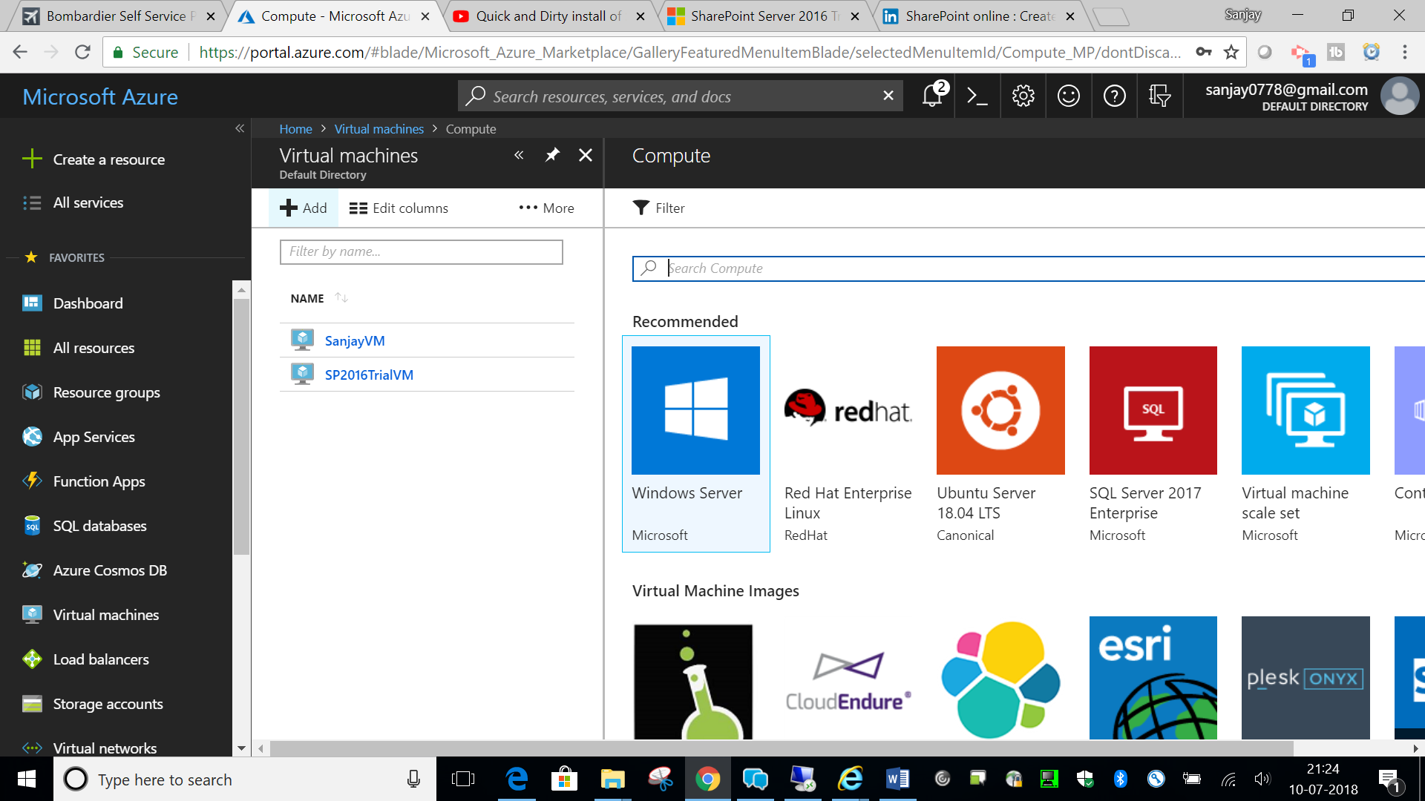

Step 2- Select Window Server 2016 Datacenter. Click on ‘Create’ button on next screen.

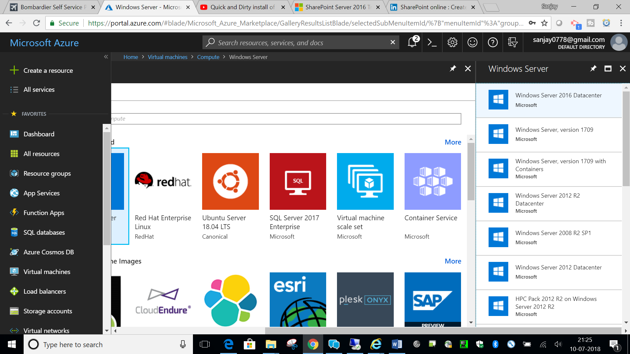

Step 3- Provide all the details for your DC VM.

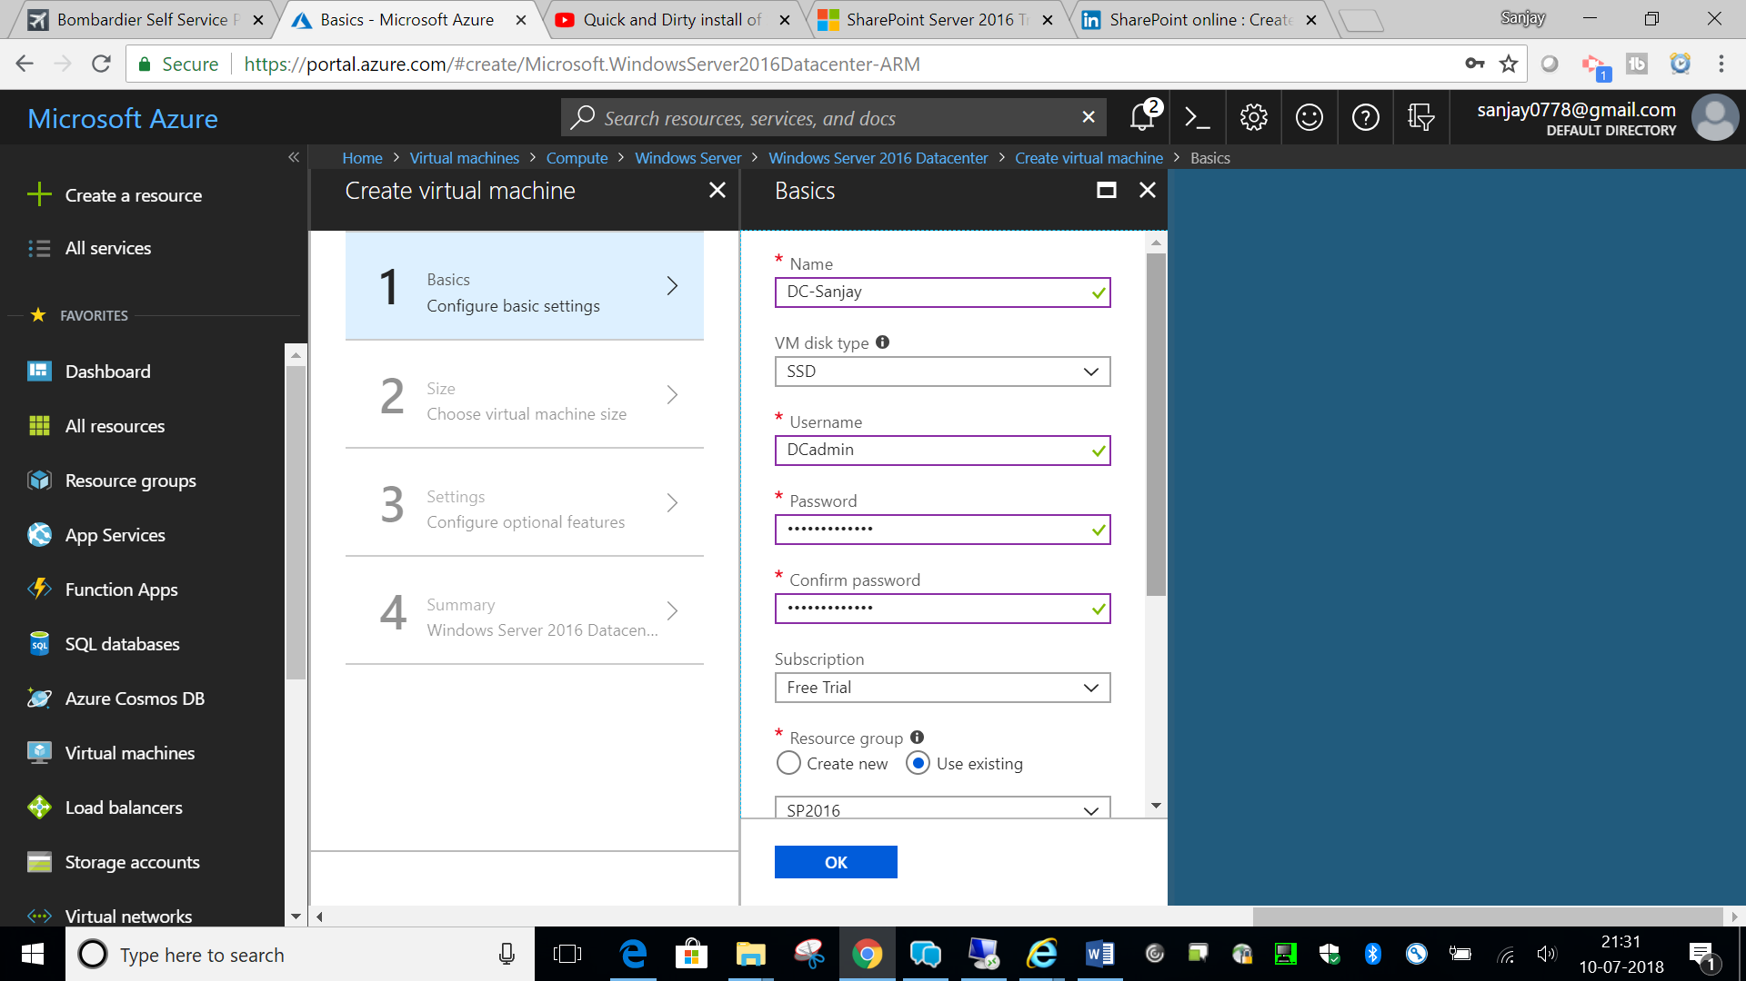

User: DCadmin

Pwd: Faizabad1234#

Step 4- Select size

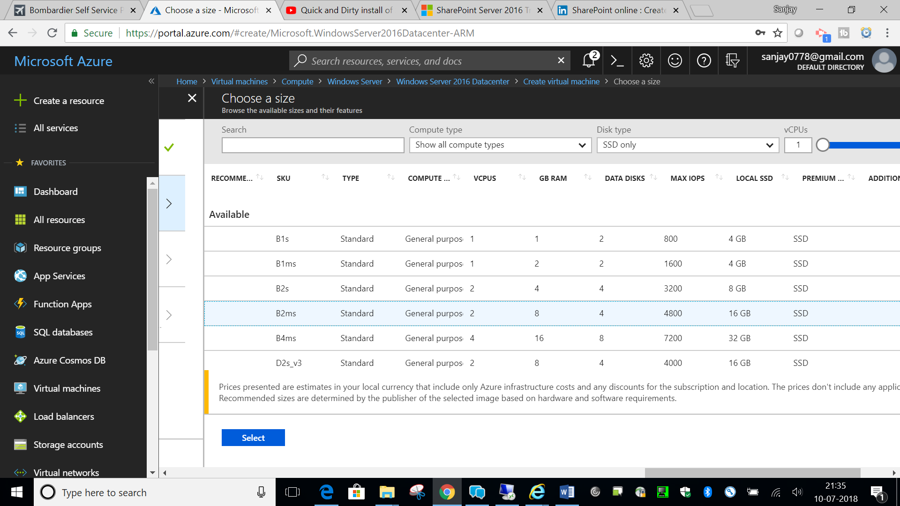

Step 5- Check the settings and click OK. We will use same Virtual Network for all connected VMs. Click on Advance in Network security group it will create Network security group (firewall)

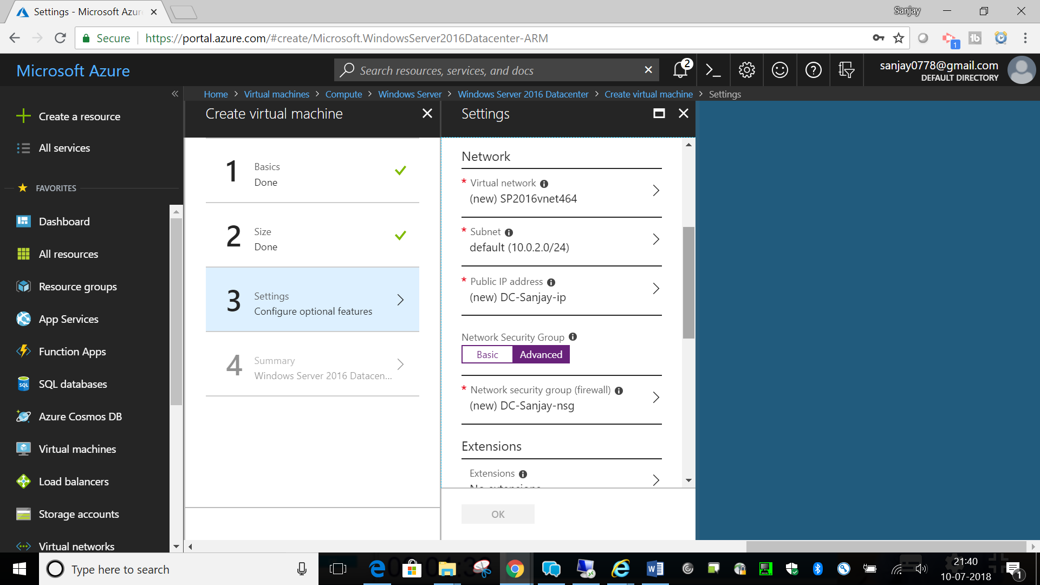

Step 6- Once validation is complete you can see summary of your DC VM

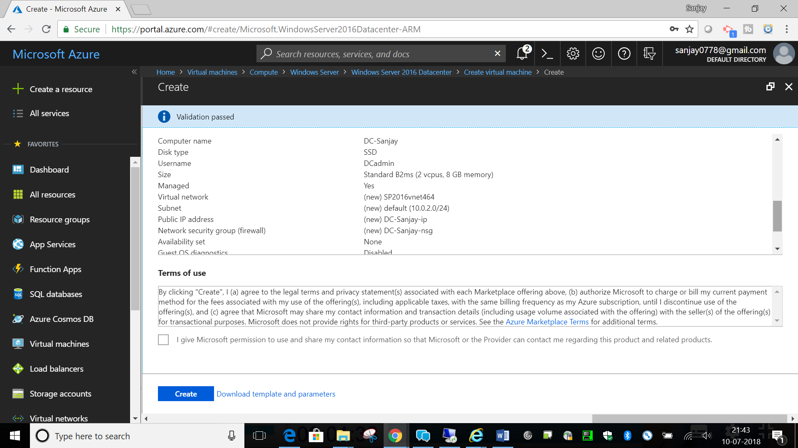

Step 7- Click on Create button to create DC VM. After VM is created, go to Networking settings.

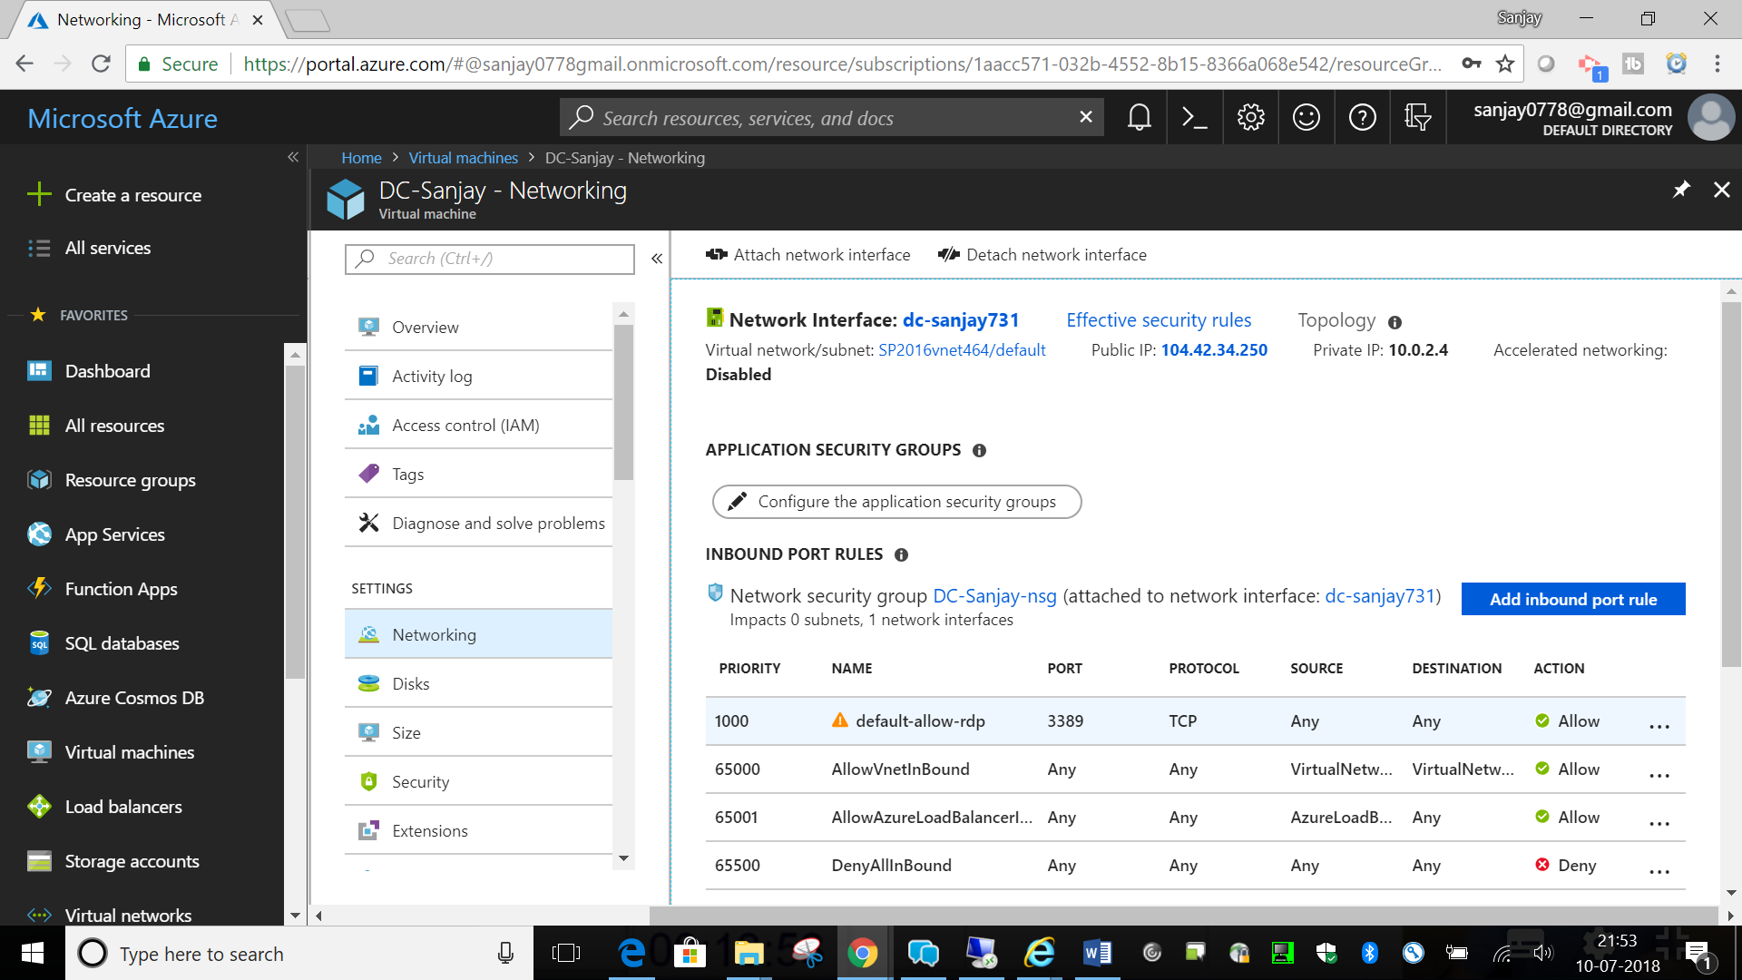

Step 8- Click on Public IP. Go to Configuration under Settings. Make IP Static

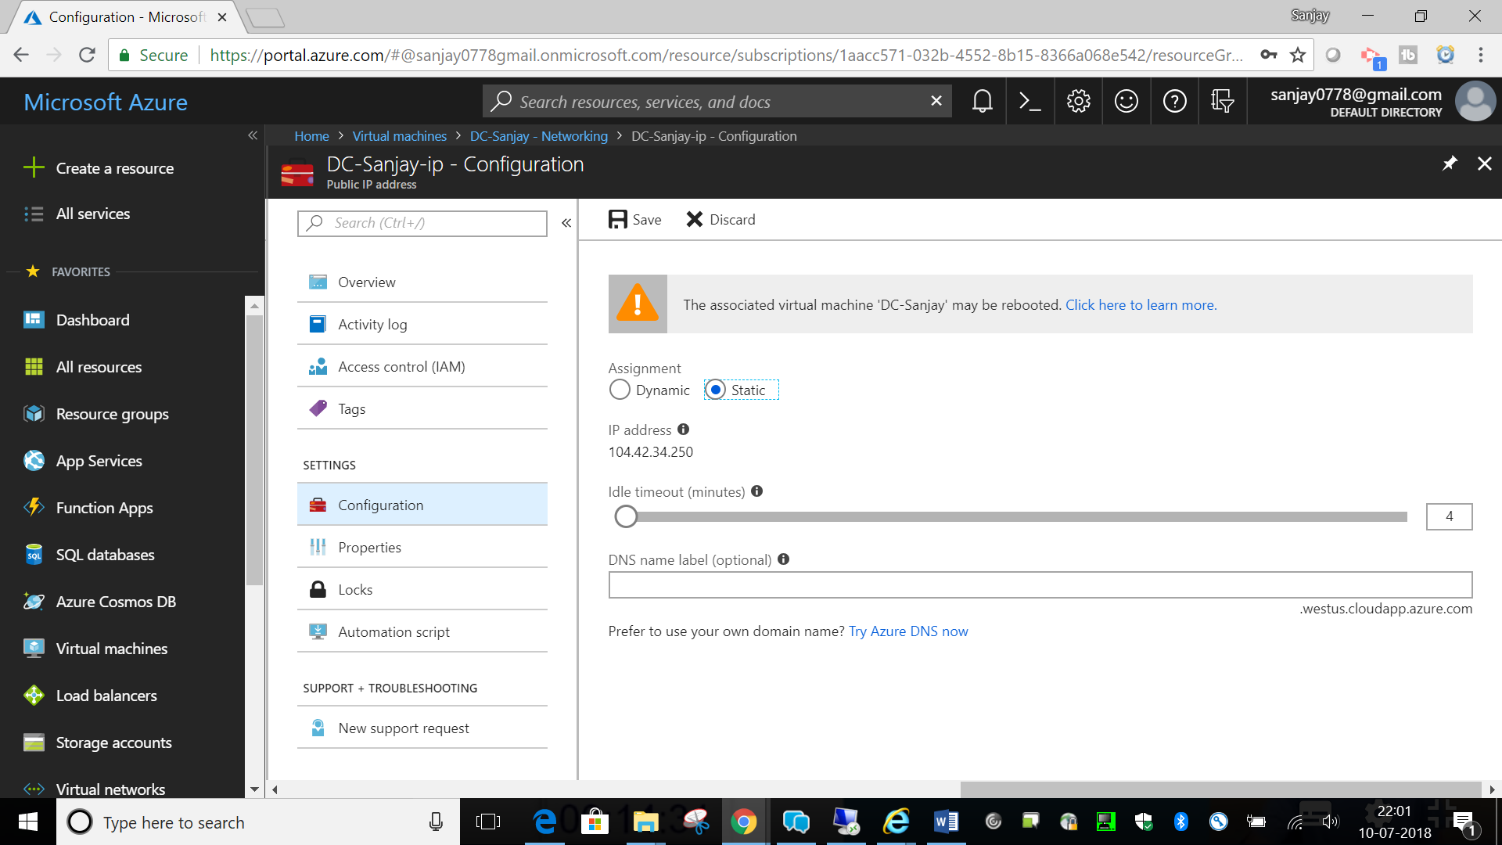

Step 9- Click on Virtual Networks in Left navigation.

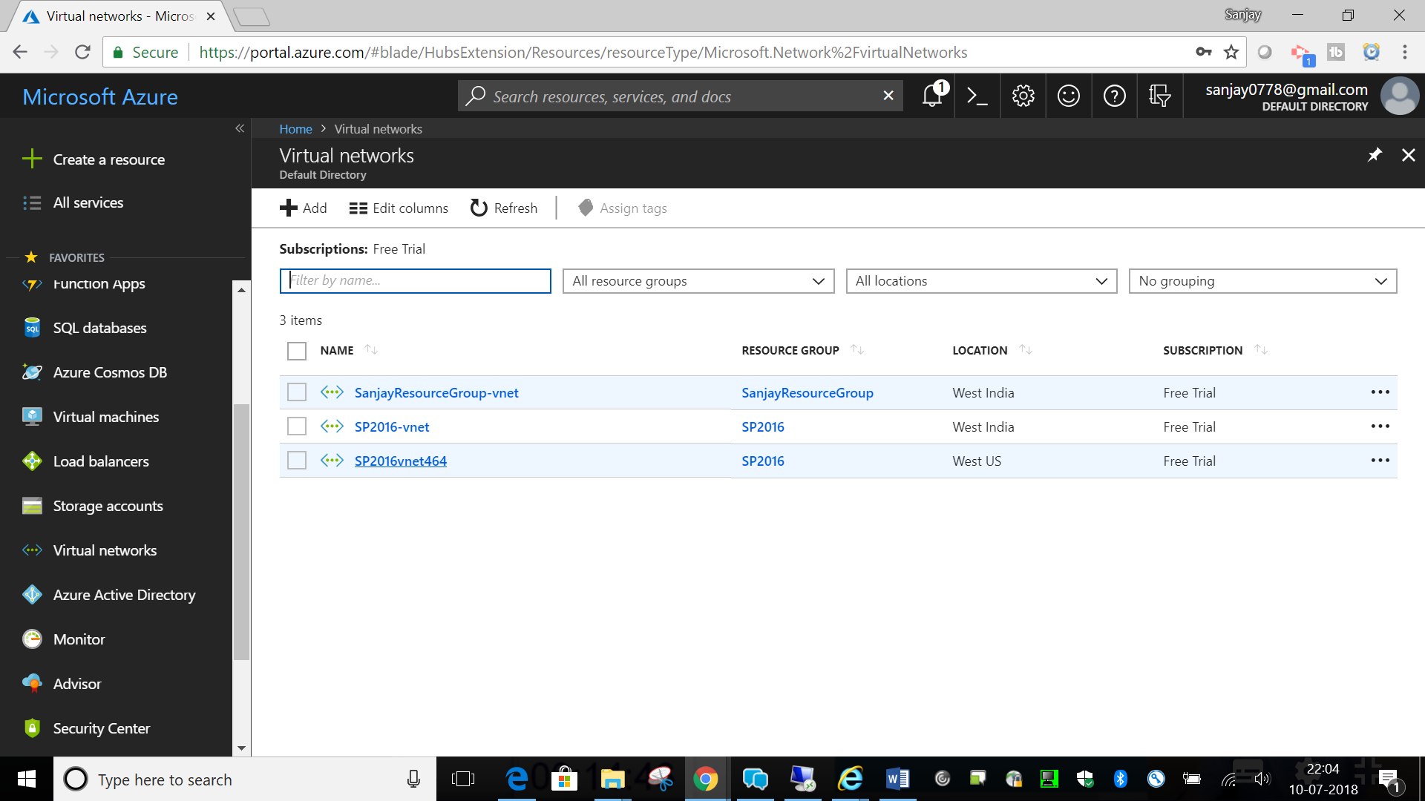

Click on our virtual network SP2016vnet464. Click on DNS Servers as shown in image

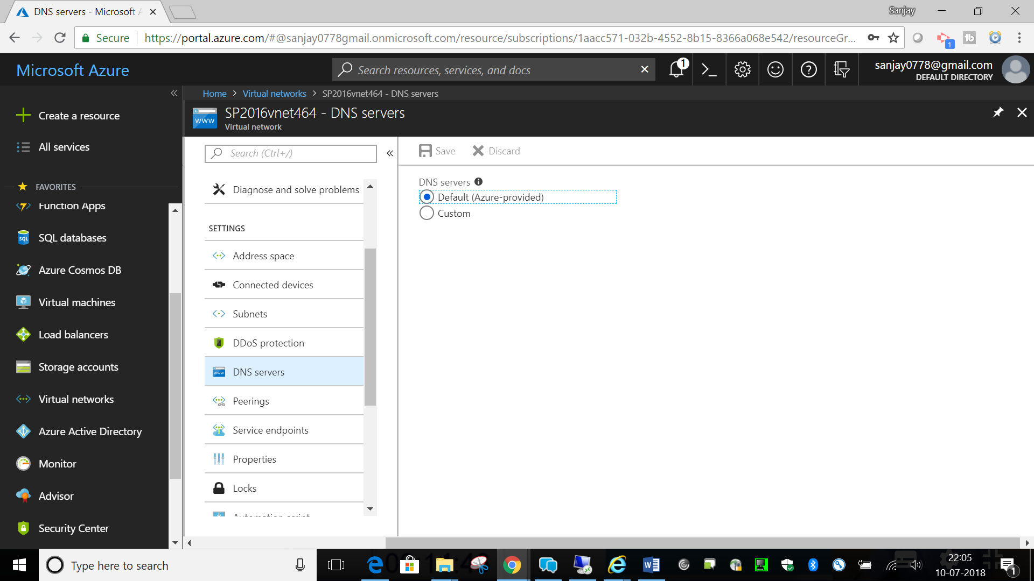

Click on Custom and provide the internal static IP of VM

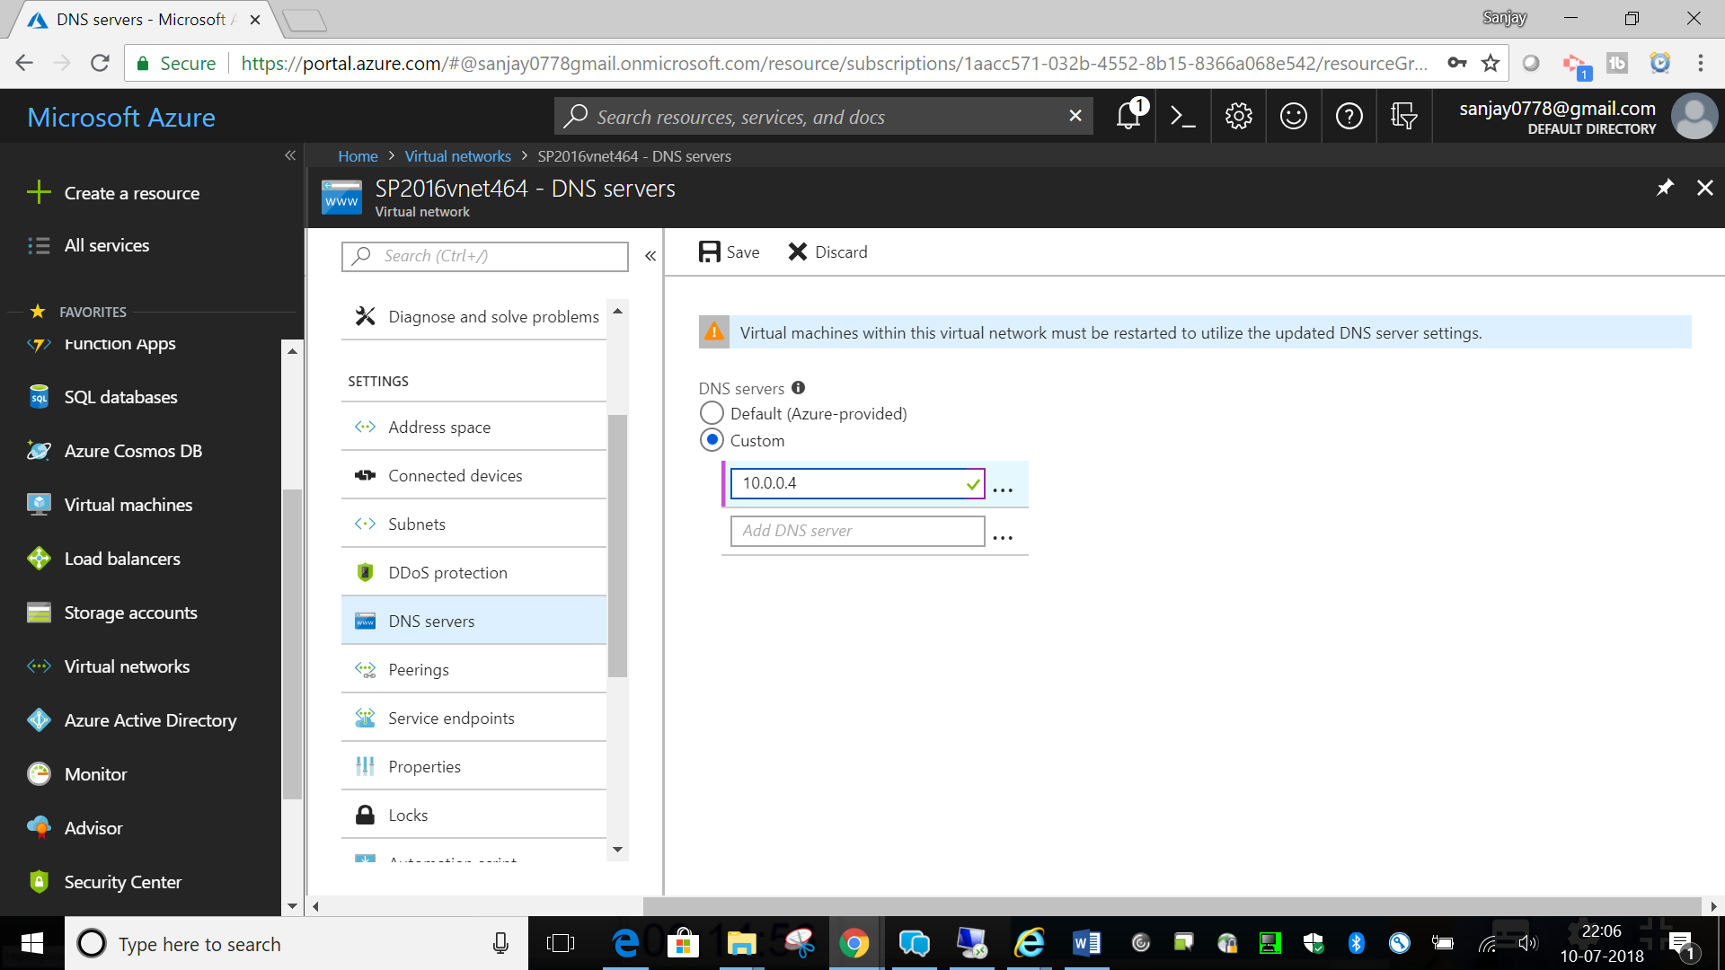

Now connect to DC VM

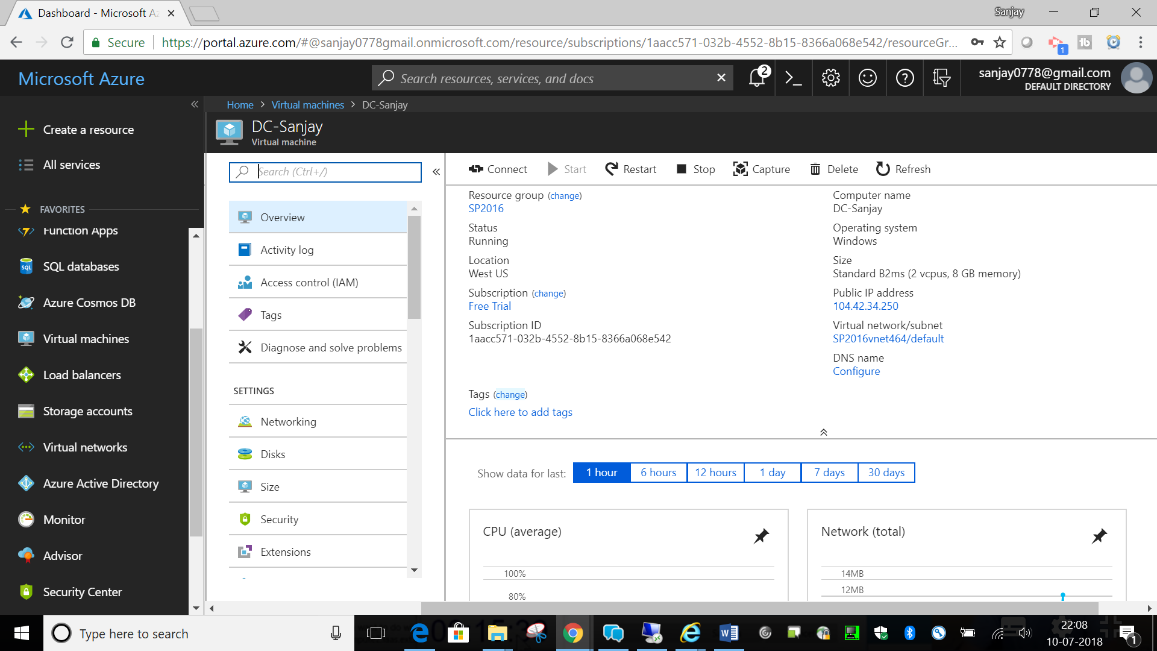

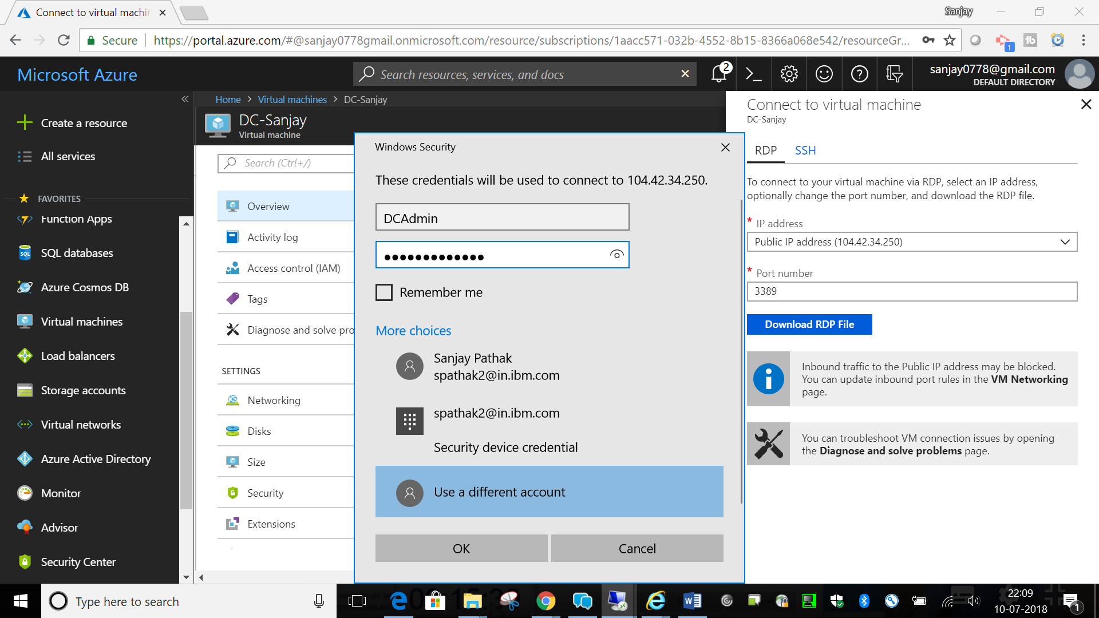

Click on Configure Local Server in Server Manager after login to your VM

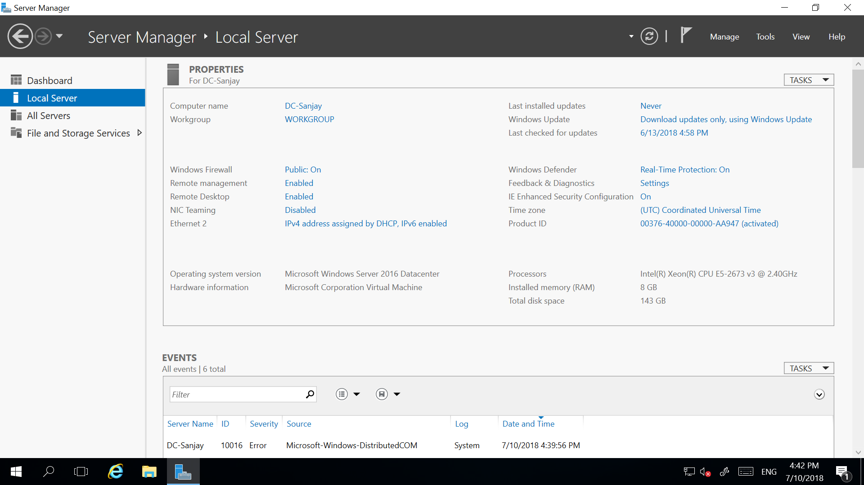

Click on ‘Add Roles and Features’

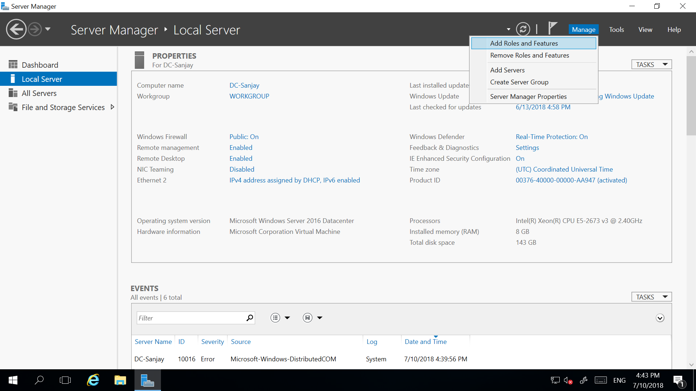

Click on Next

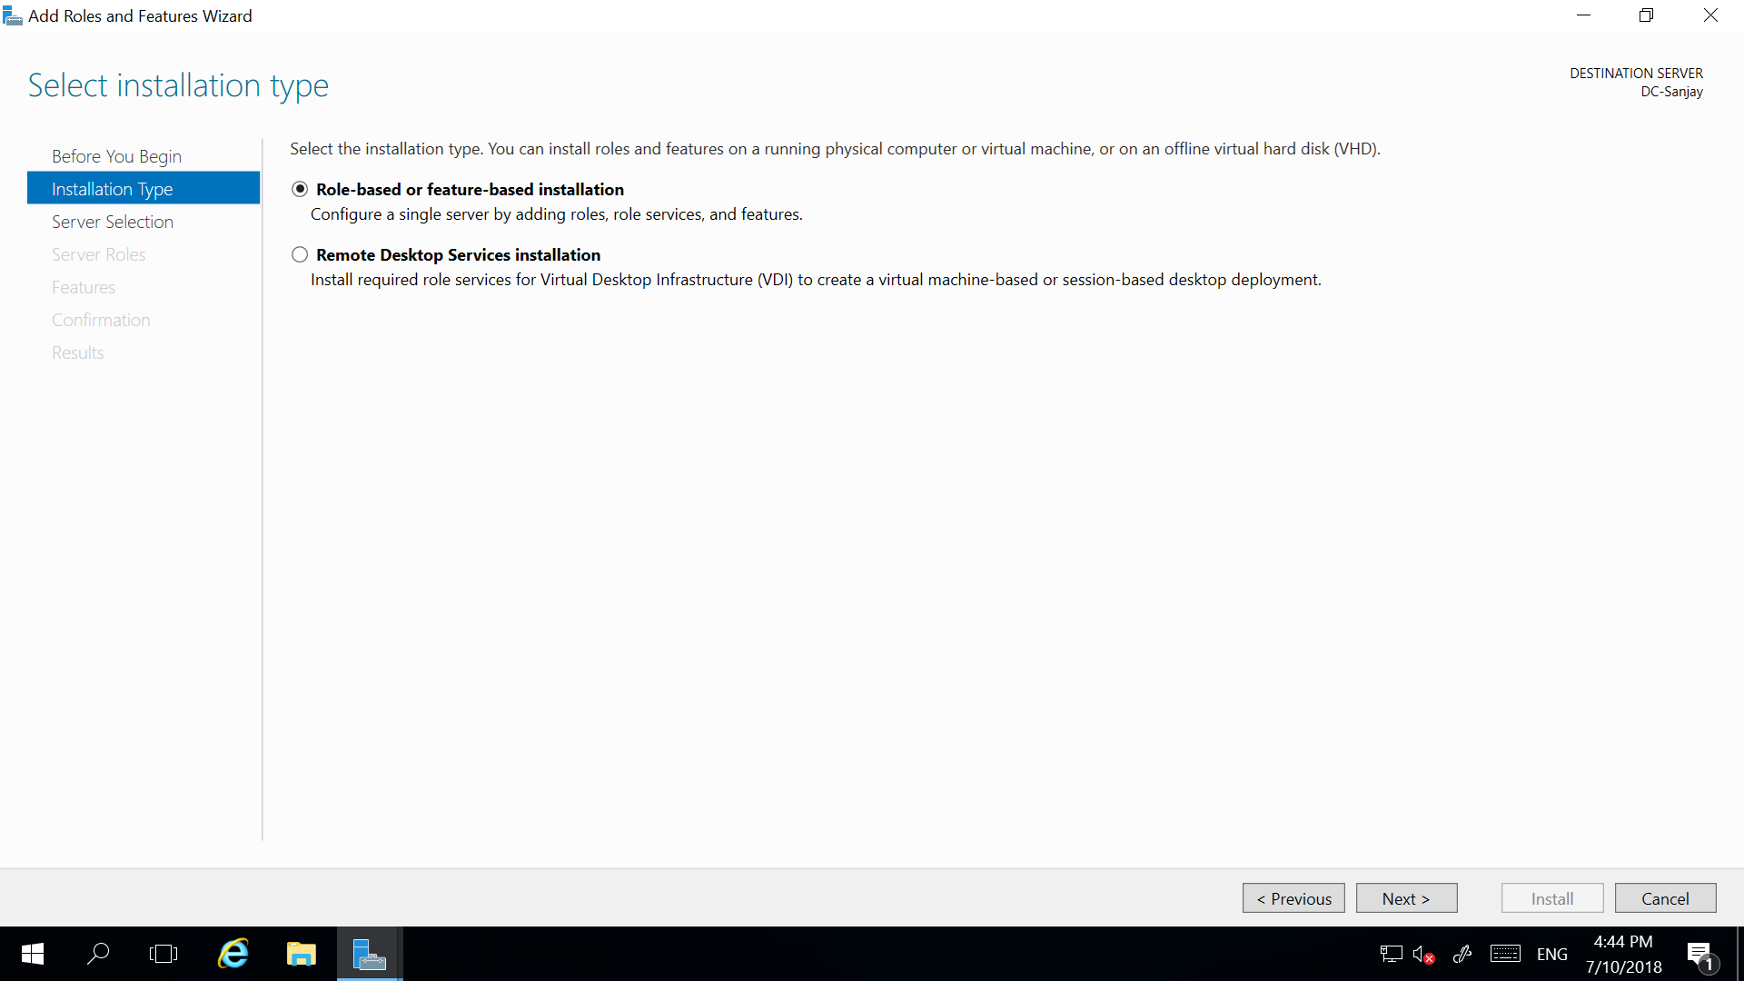

Click on Next

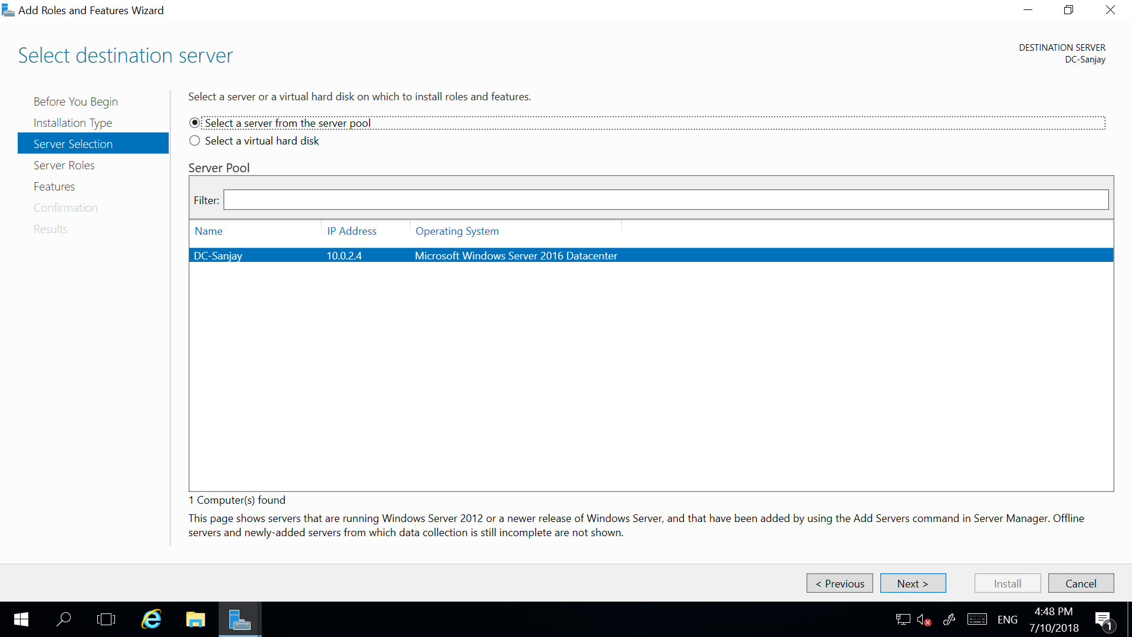

Next Click Active Directory domain services. Click on Add Features.

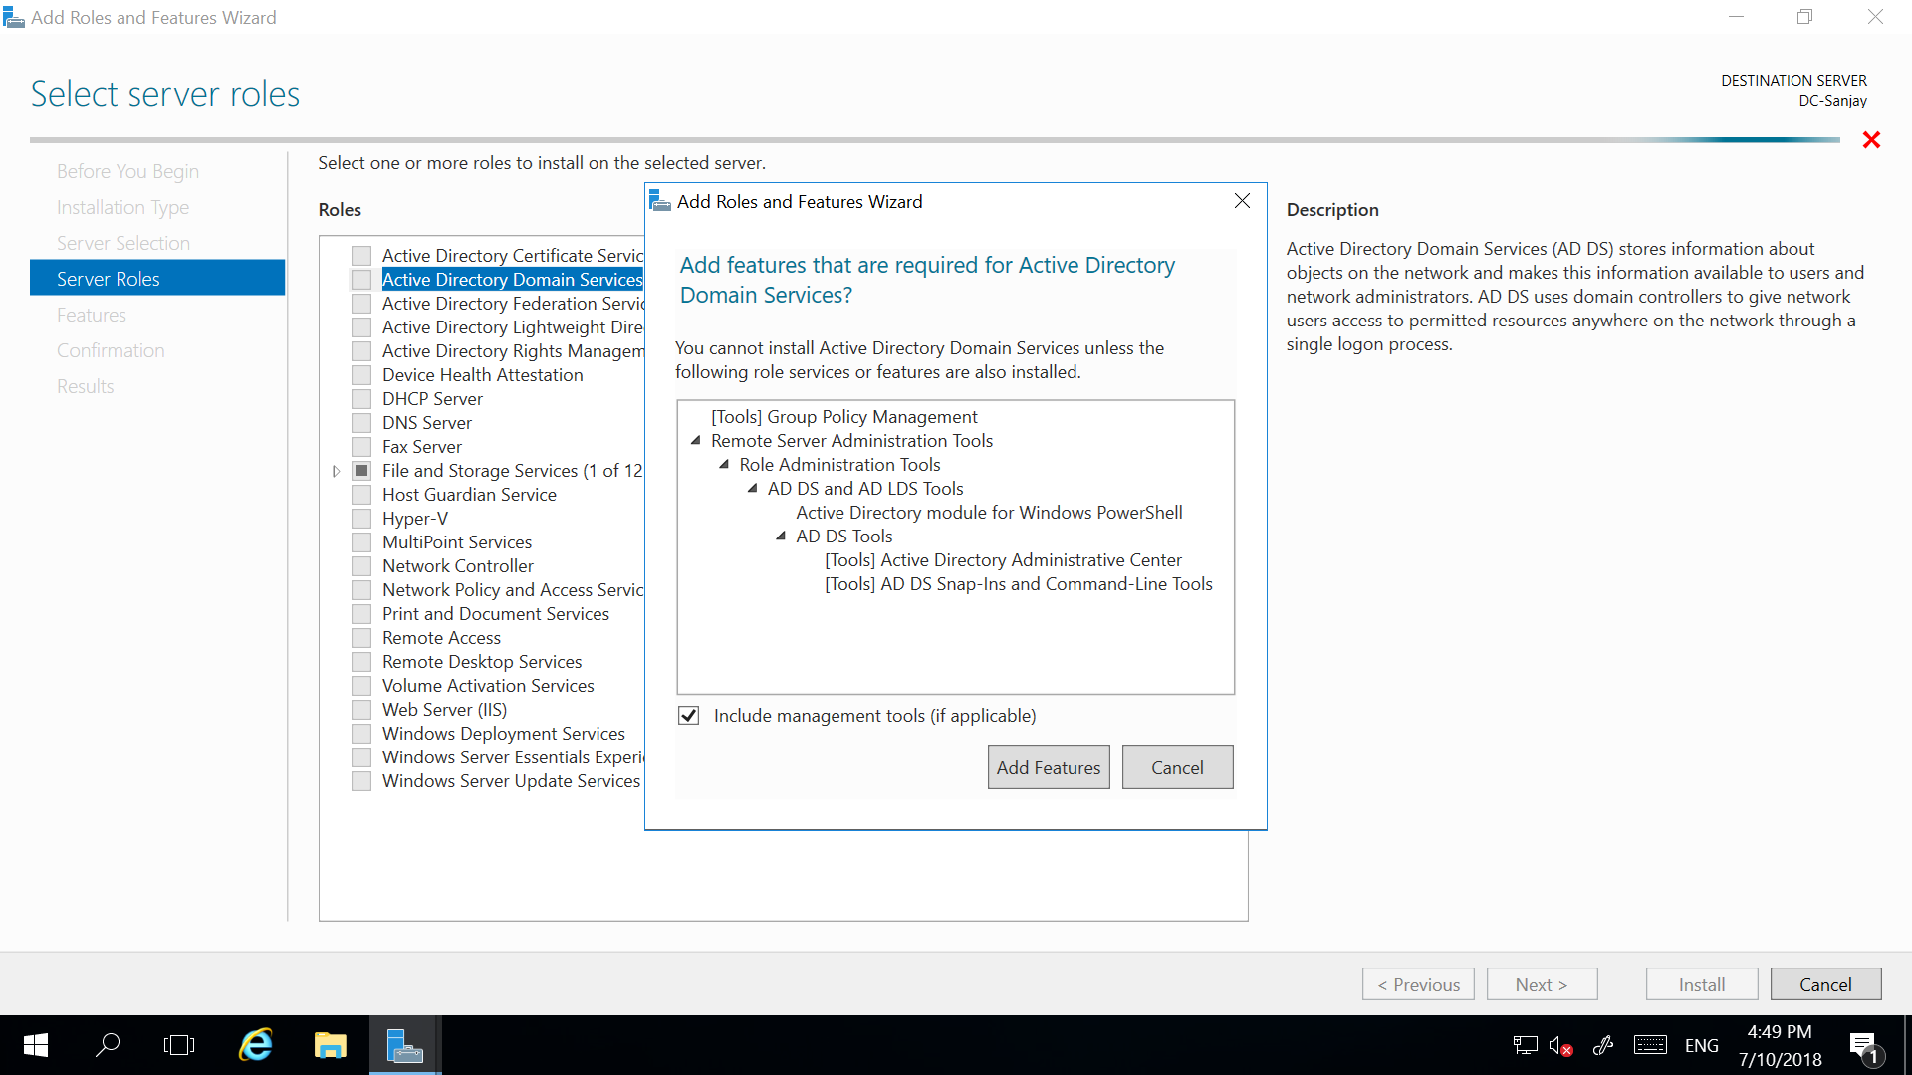

Next

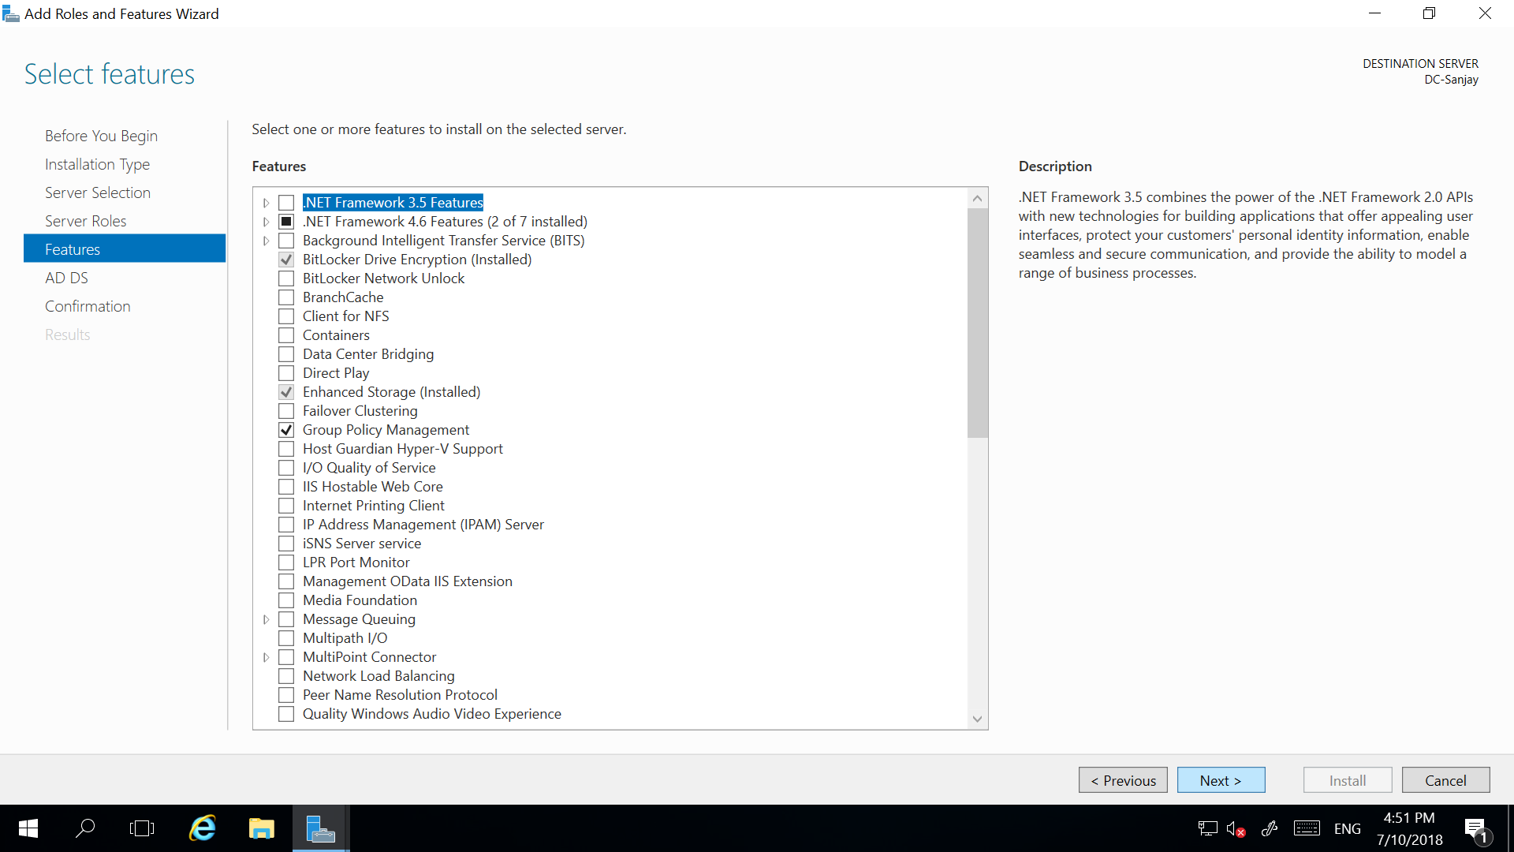

Next

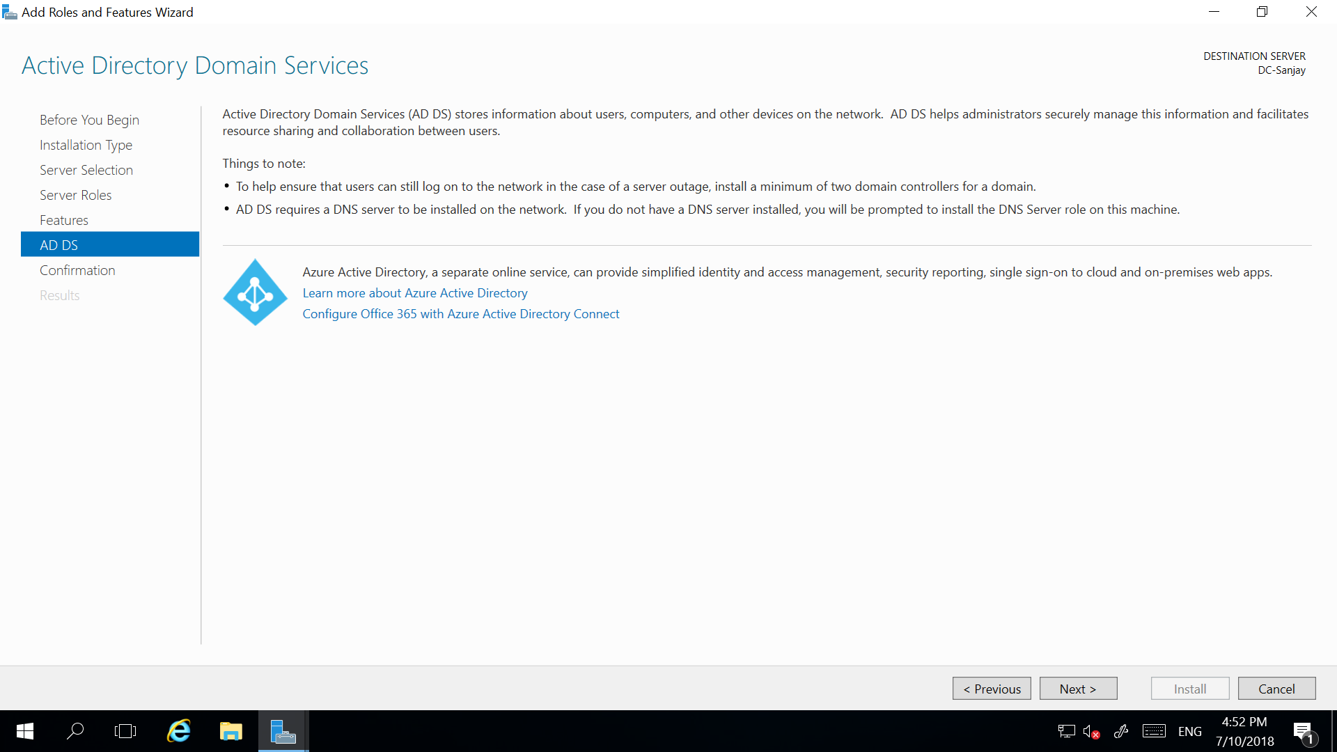

Next

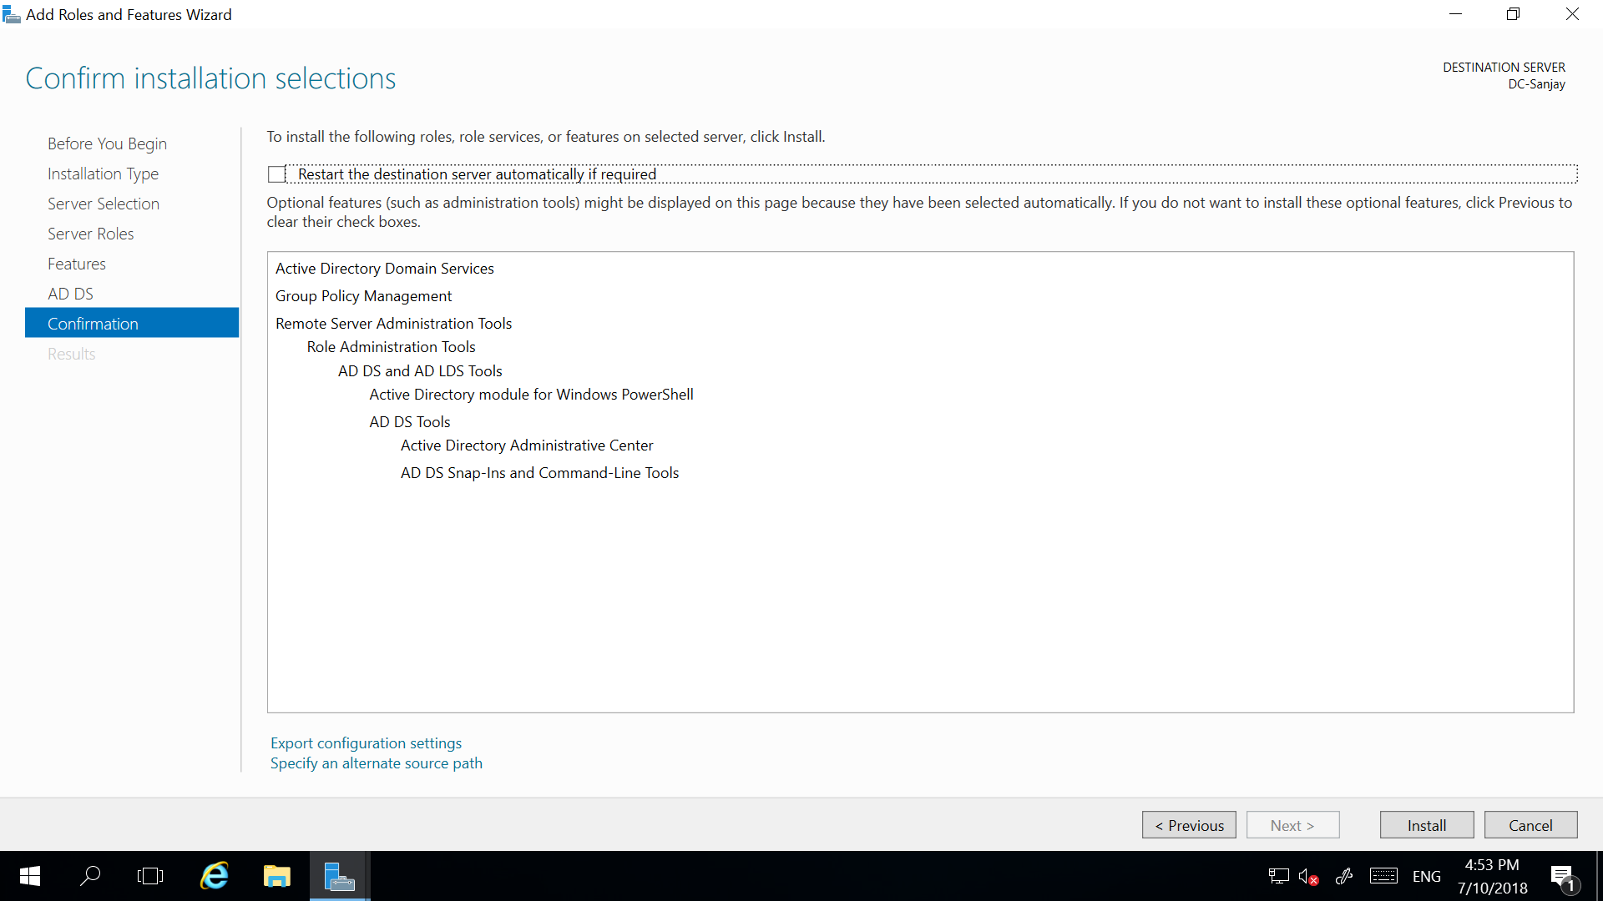

Install

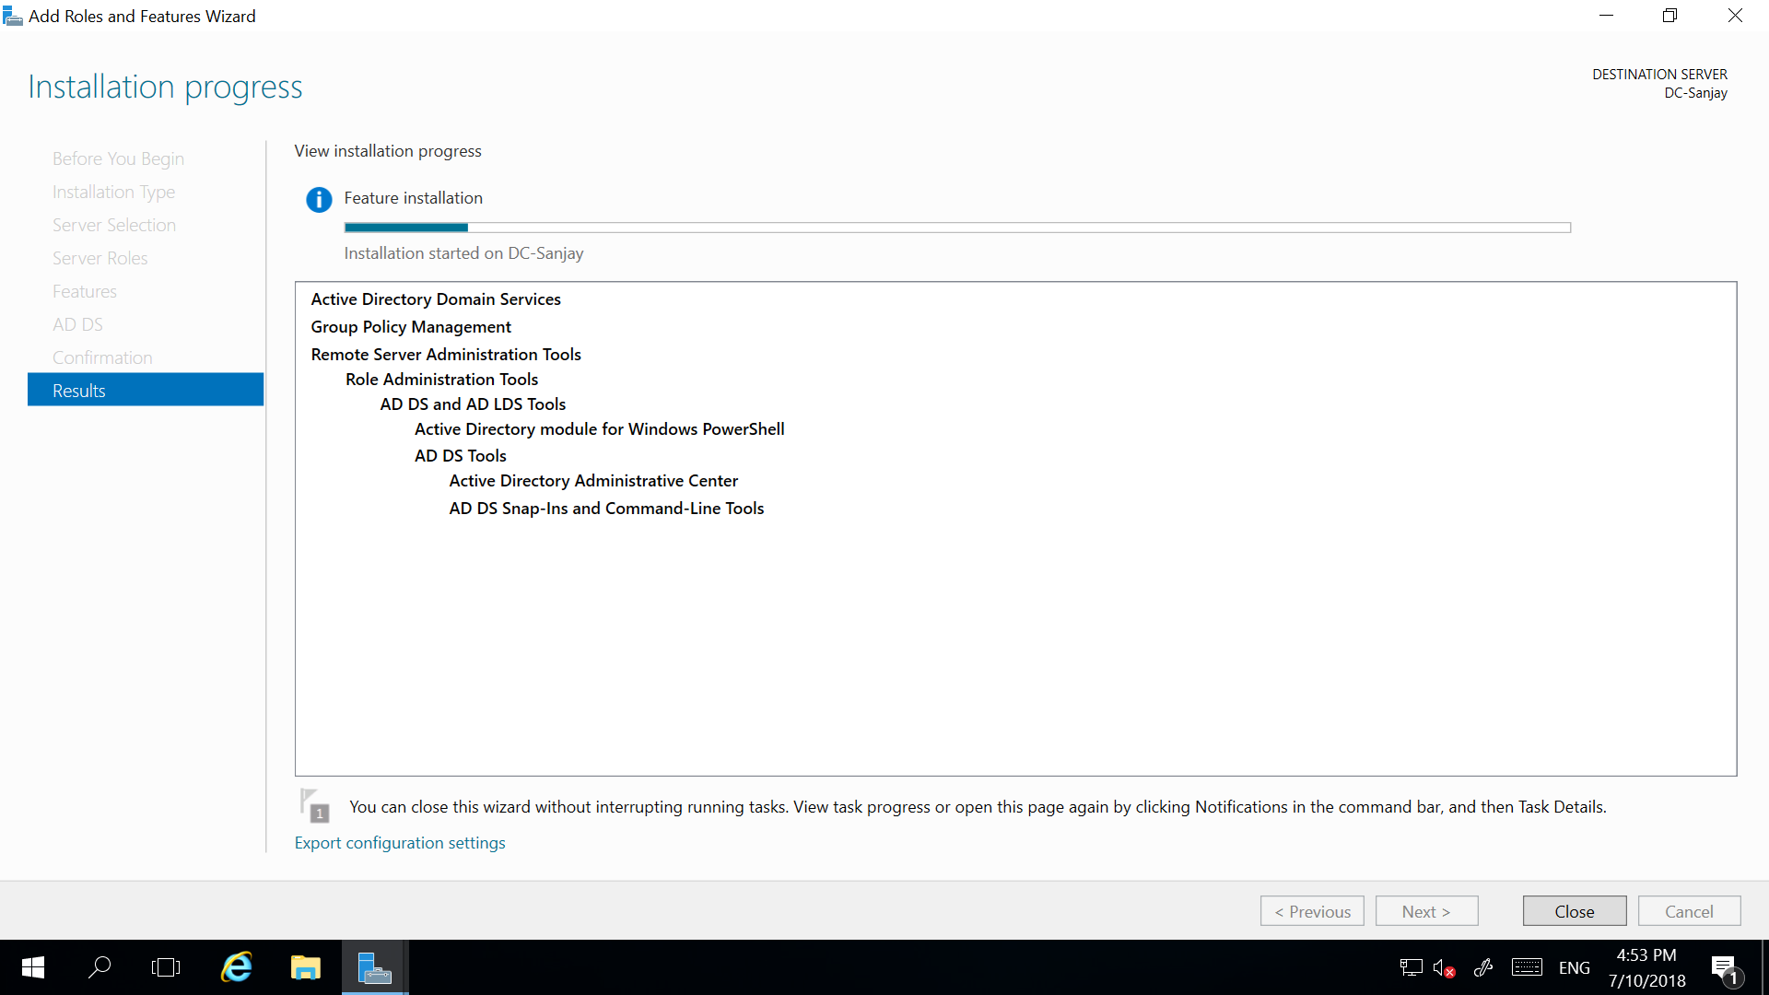

Close after installation succeeded.

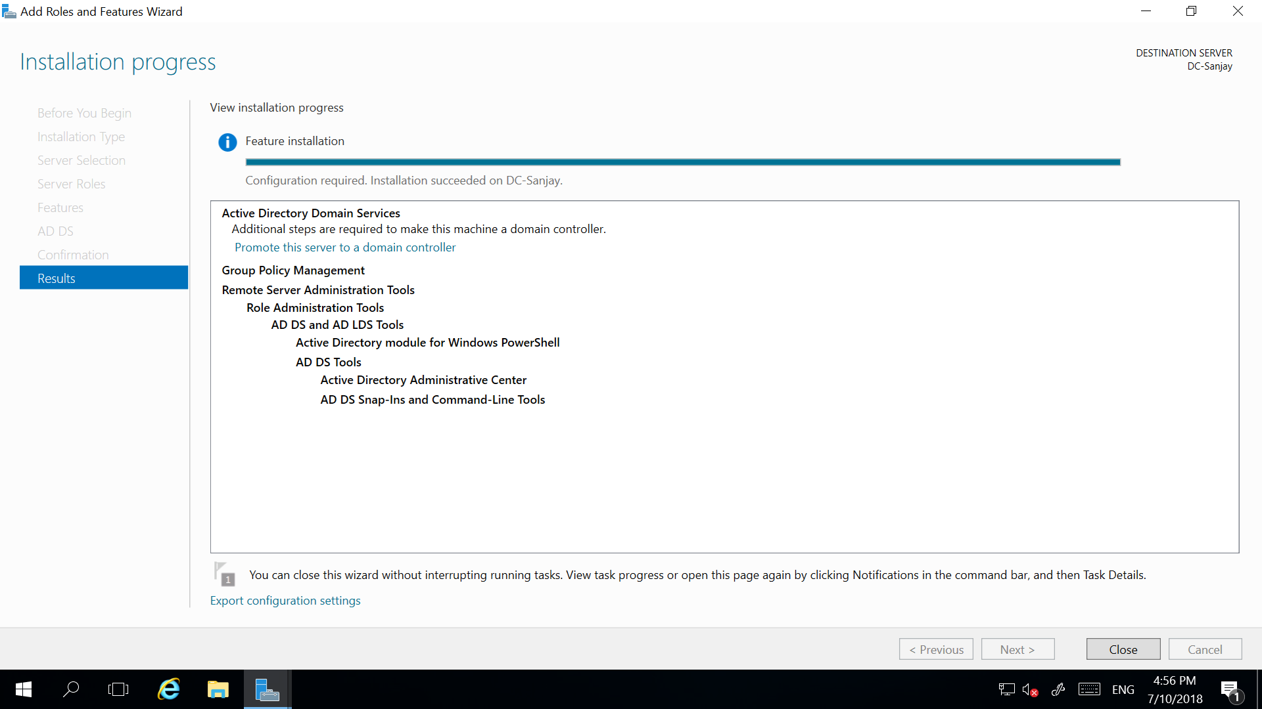

Click on warning on top right

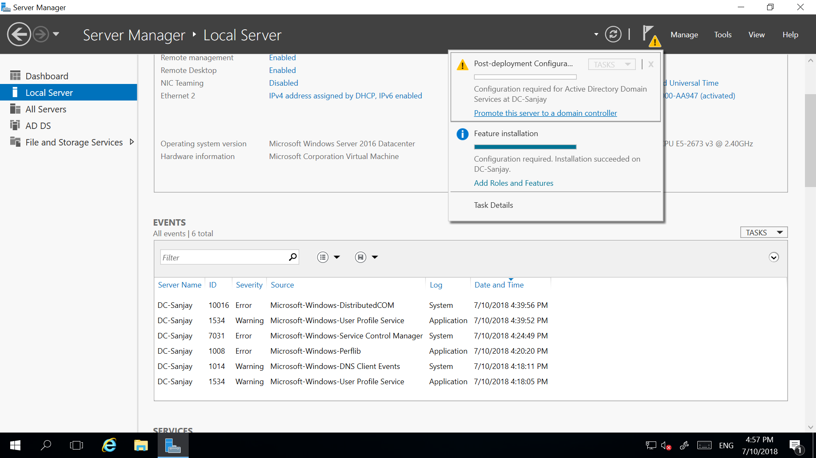

Click Add new forest. Give root domain name.

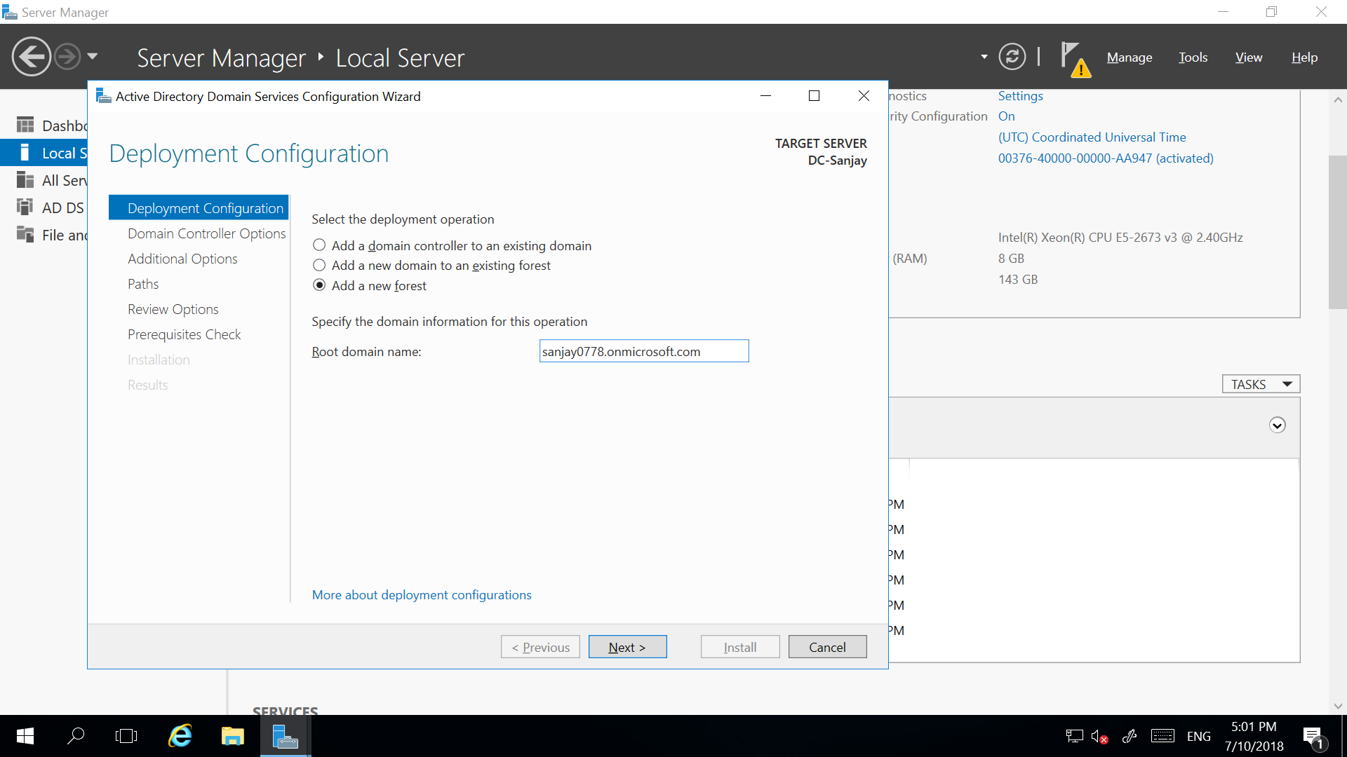

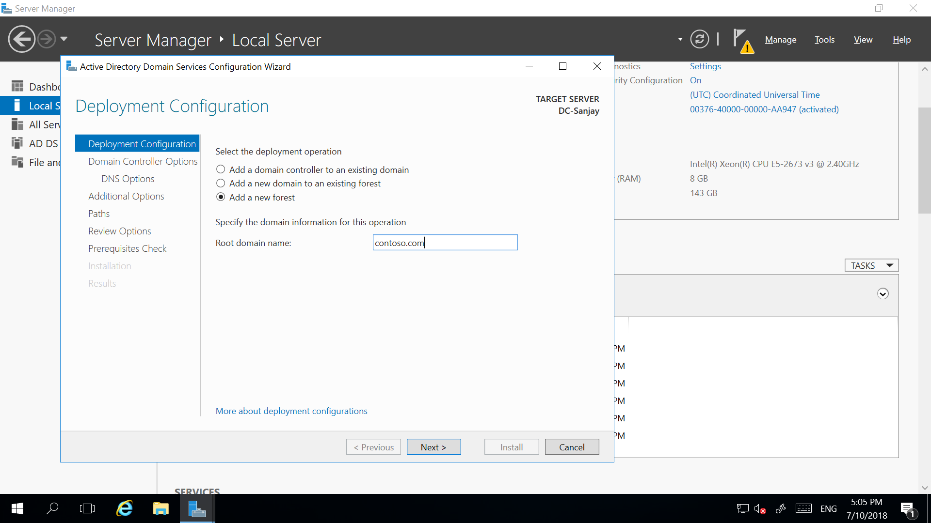

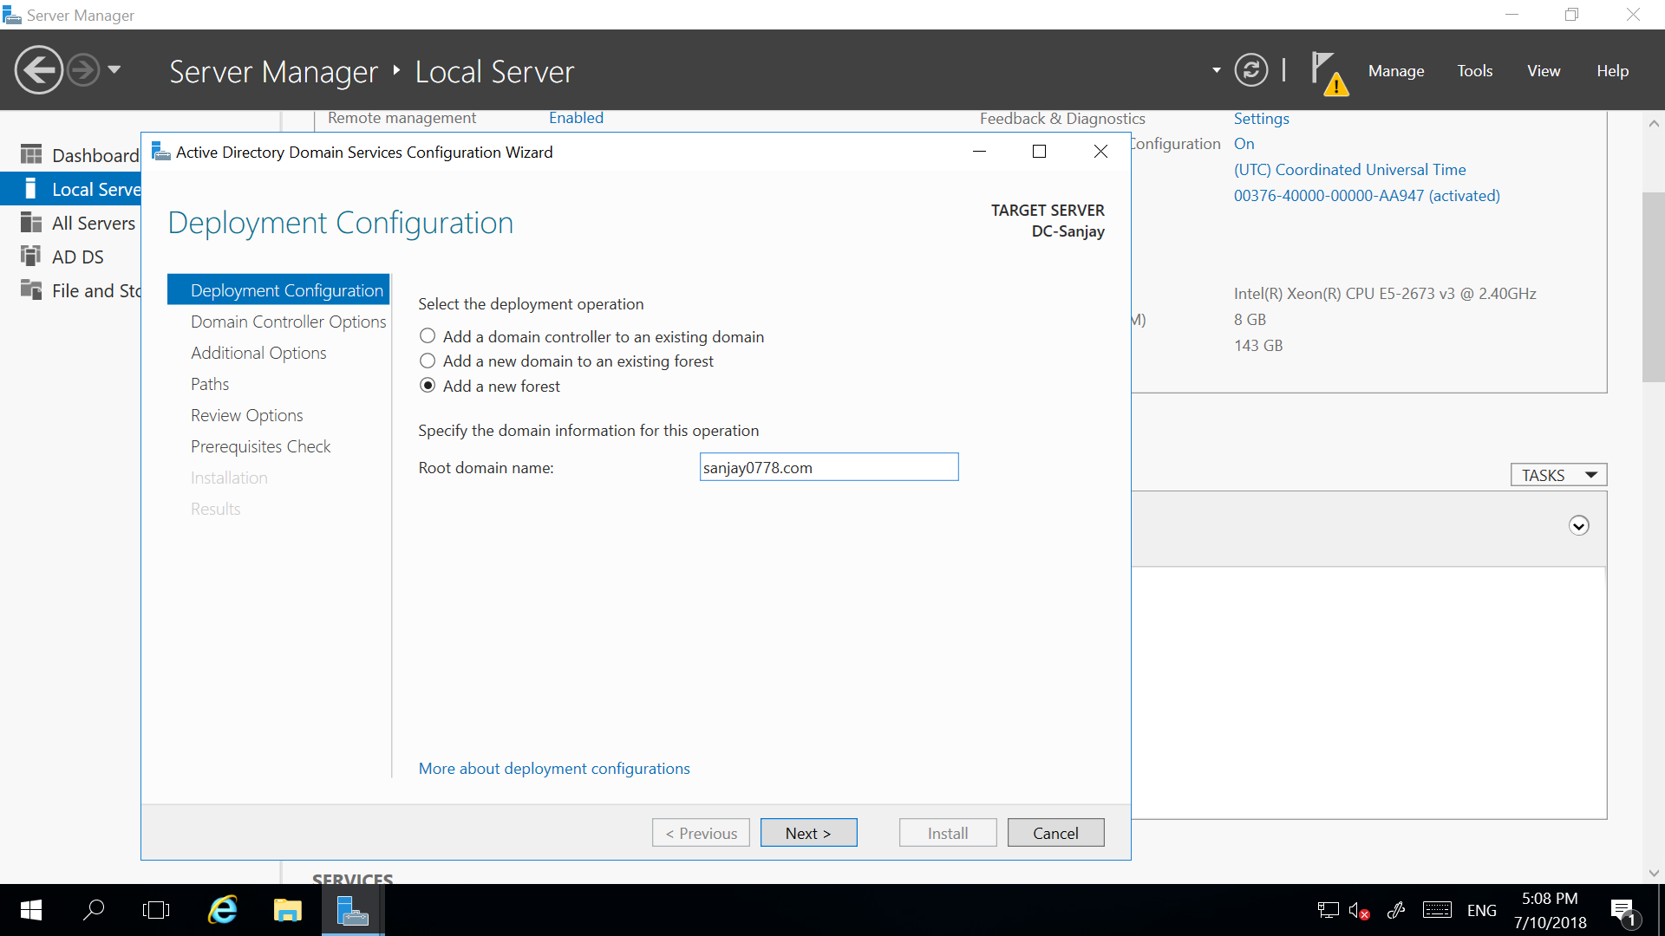

Click next

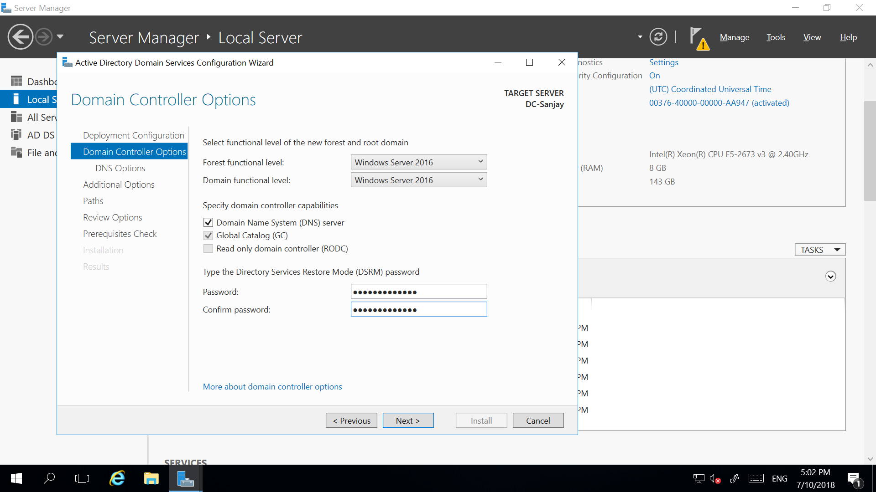

Give recovery password (Faizabad1234#) click next